**Averi Bogucki’s Final Project**

**Lab Goal:** Analyze the problem and determine a method or determine methods to help you solve it. Remember, all your commands must fulfill all the preconditions and postconditions asked of you. Use if, if else, and while statements as much as possible.

**Description:** To solve this lab, you must find a way to get out of the maze. Follow all the preconditions - they will help you find your way out. Your Jeroo must not jump into water or nets. However, you can break a net by tossing a flower into it. The number of flowers you will need are already programmed into the template. You should be able to solve the maze and then come back out with the two methods in the Jeroo methods already created for you. Good luck!

**Starting Screen Files Needed:**

JerooFinalProjectTemplate.jsc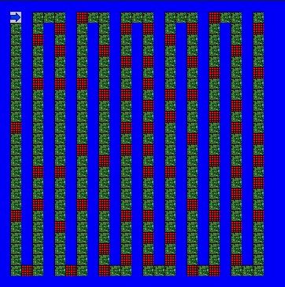

JerooFinalProjectMaze.jev

**Preconditions:**

* Am I facing the right way?
* Is it clear ahead or not?
* If not, should I turn left or right?
* Do I stop?

**Ending Screen**

**Postconditions:**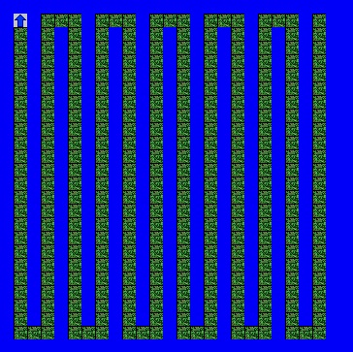

* Successfully go through the maze
* Jeroo is not in water or a net
* Jeroo is facing north
* Jeroo stops after solving maze and then comes back out